
National Textile University
Department of Computer Science
Subject:
Mobile application and development
Submitted To:
Sir Rehan Sarwar
Submitted By:
Noor ul Ain
Registration No:
23-NTU-CS-1135
Lab no:
7
Semester:
6th

Phase 1: GestureDetector
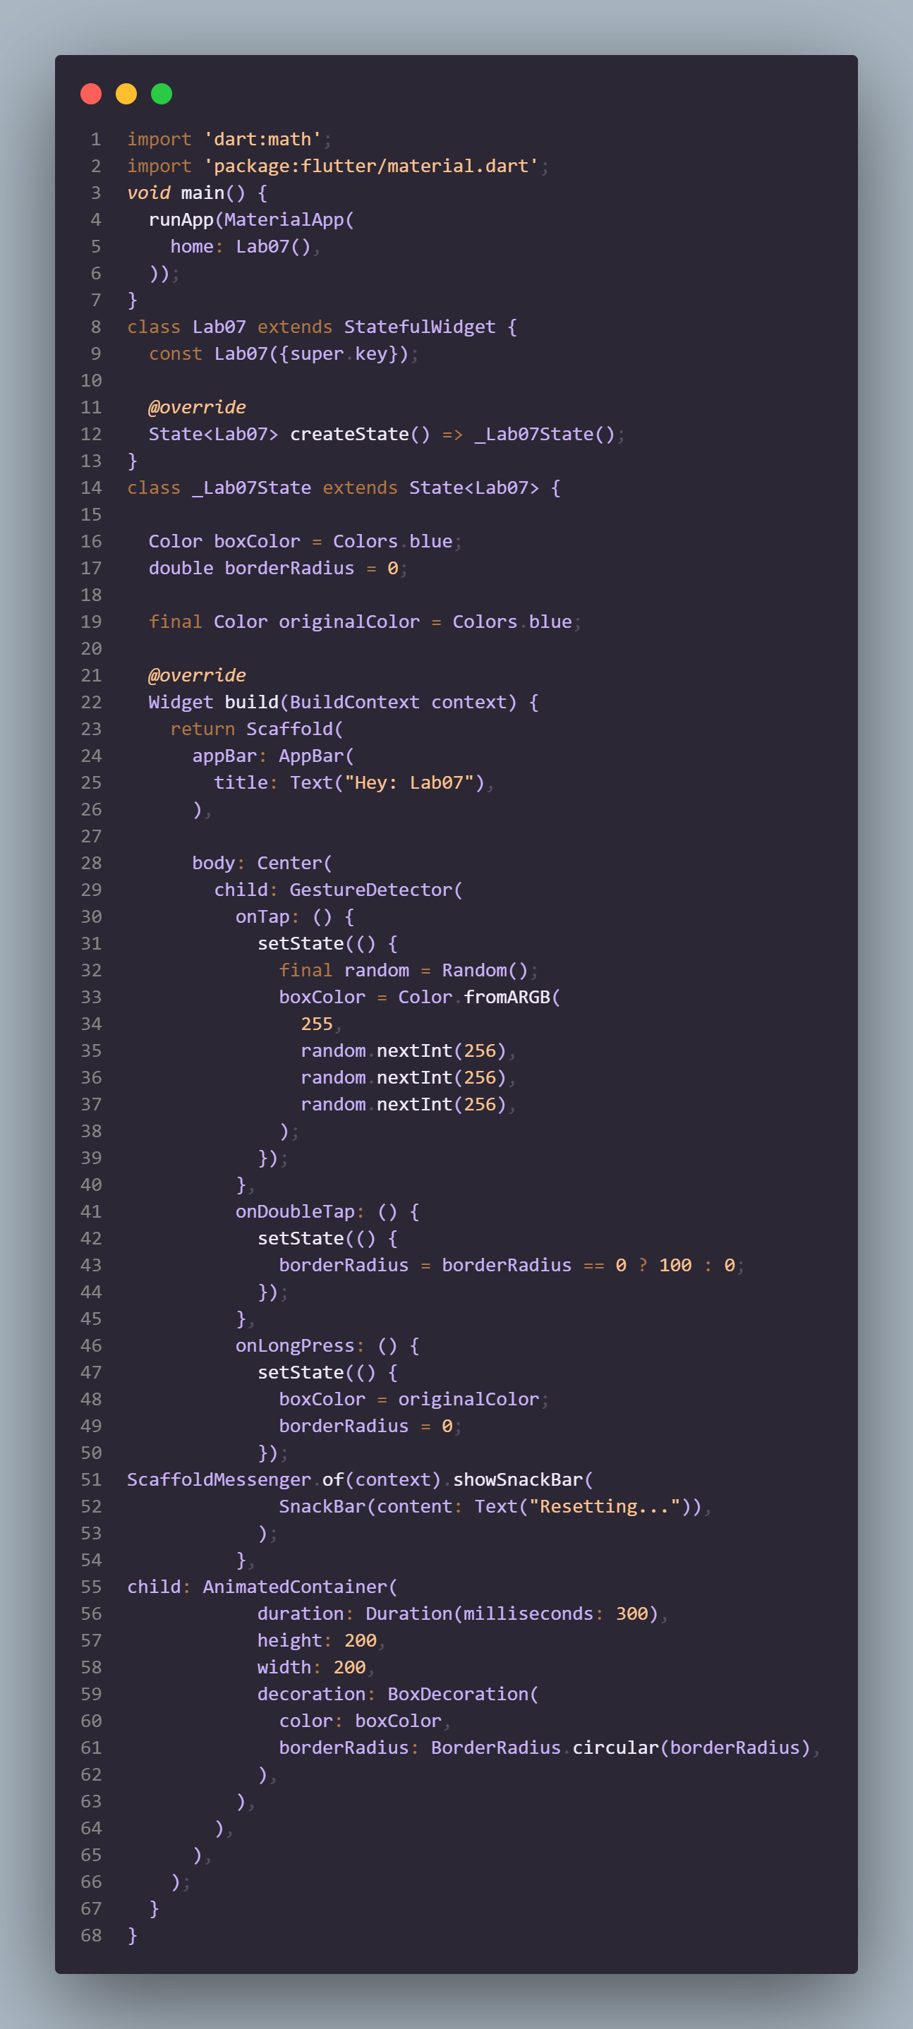
Task 1.1: Create a Container (200x200) with a unique background color.
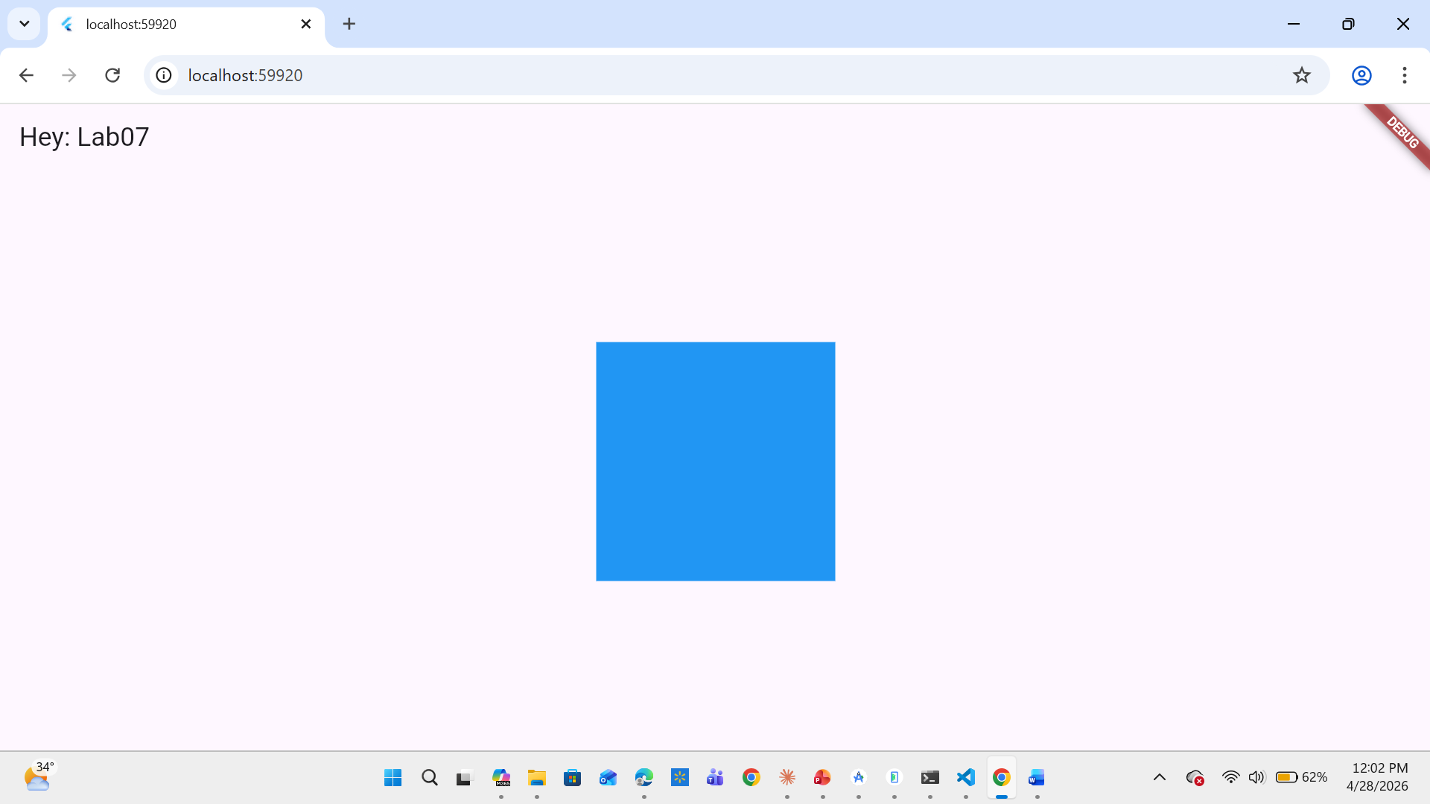
Task 1.2: Wrap the container in a GestureDetector.
Task 1.3: Logic Implementation:
- onTap: Change the container's color to a random Colors value.
- 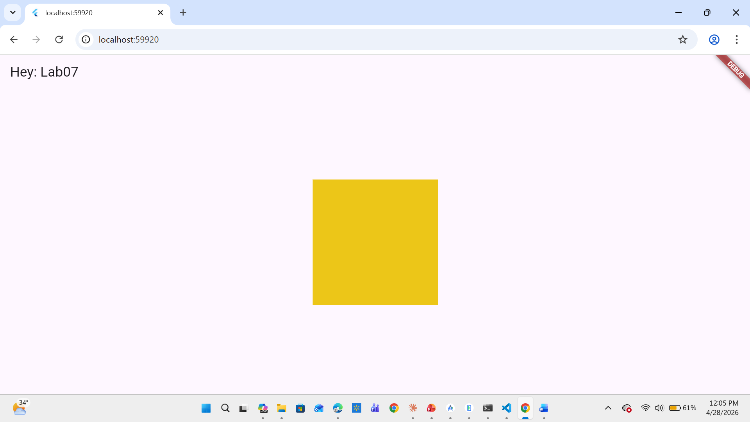
- onDoubleTap: Toggle the borderRadius between 0 and 100 (Square to Circle).
- 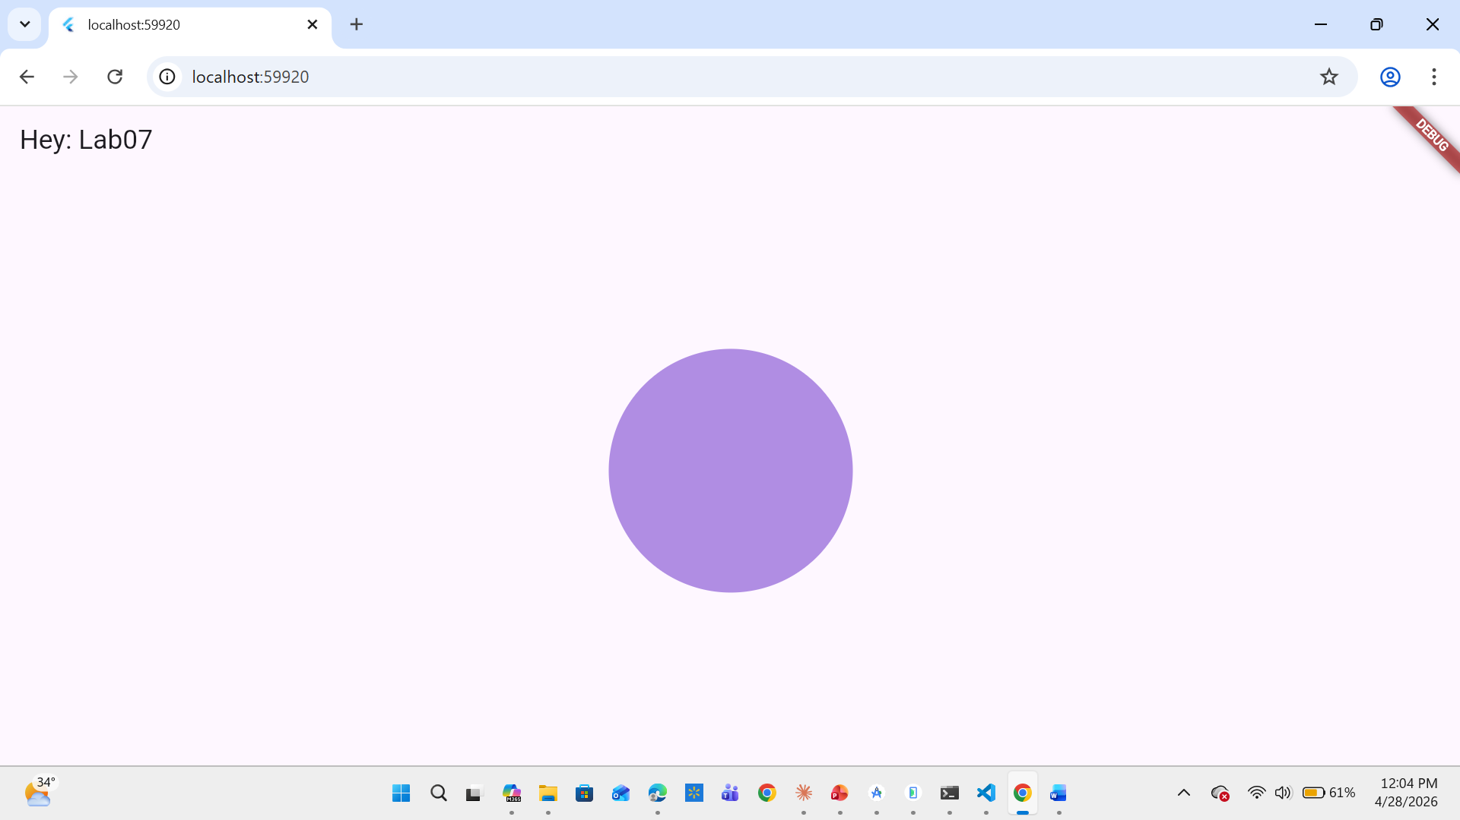onLongPress: Show a SnackBar saying "Resetting..." and return the box to its original state.
- 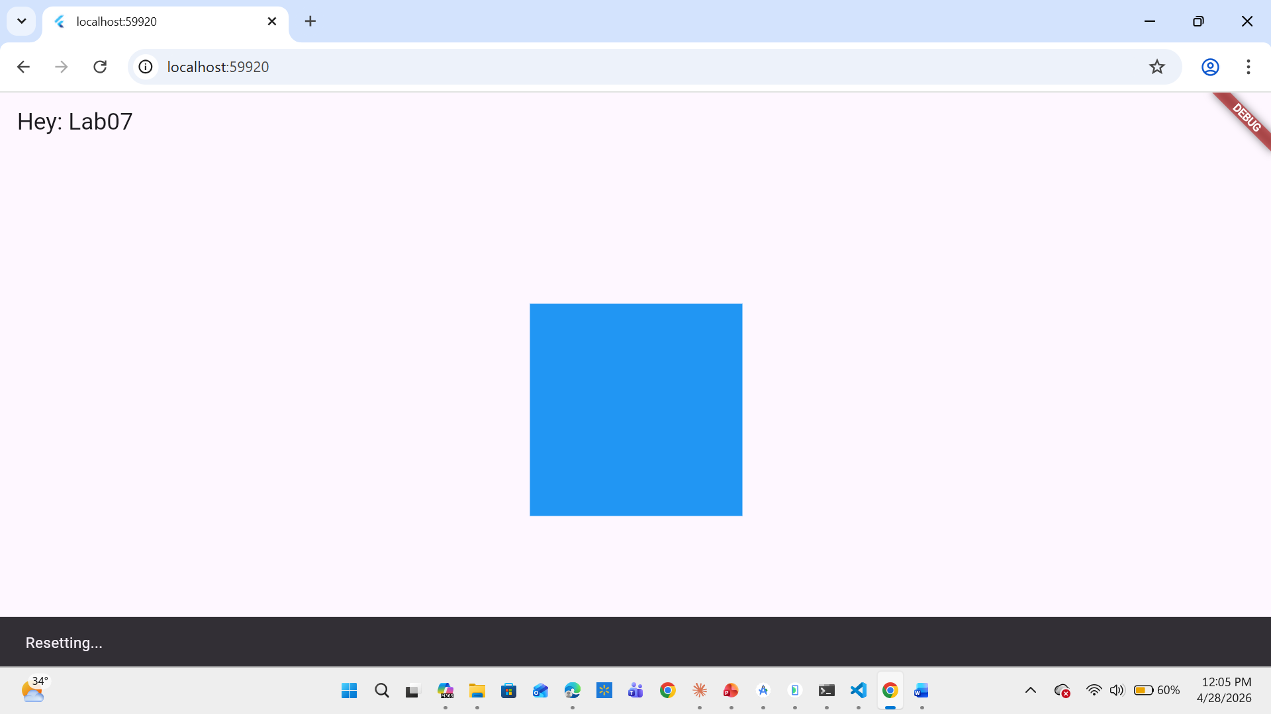

Phase 2: Sliders
Task 2.1: Create a vertical Column containing a Text widget displaying a "Value" variable.
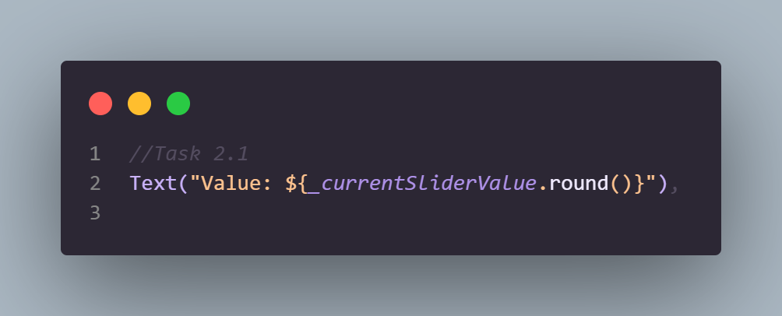
Task 2.2: Add a Slider widget:
- Set min to 0.0 and max to 100.
- Set divisions to 10 to create discrete steps.
- Update the "Value" text in real-time within onChanged.
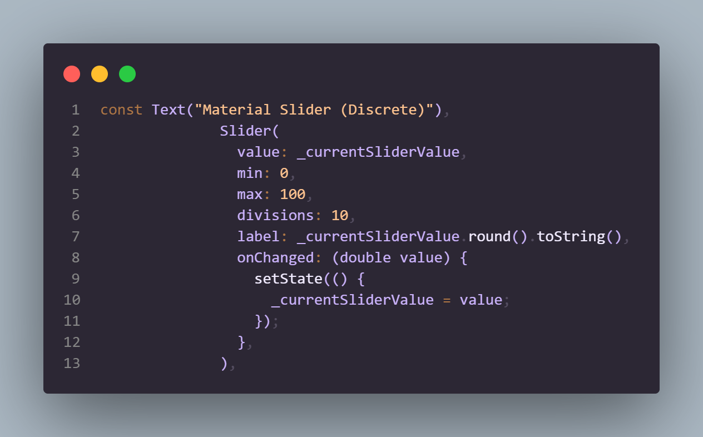
Task 2.3: Implement a CupertinoSlider below the Material one to observe the difference in native "look and feel.
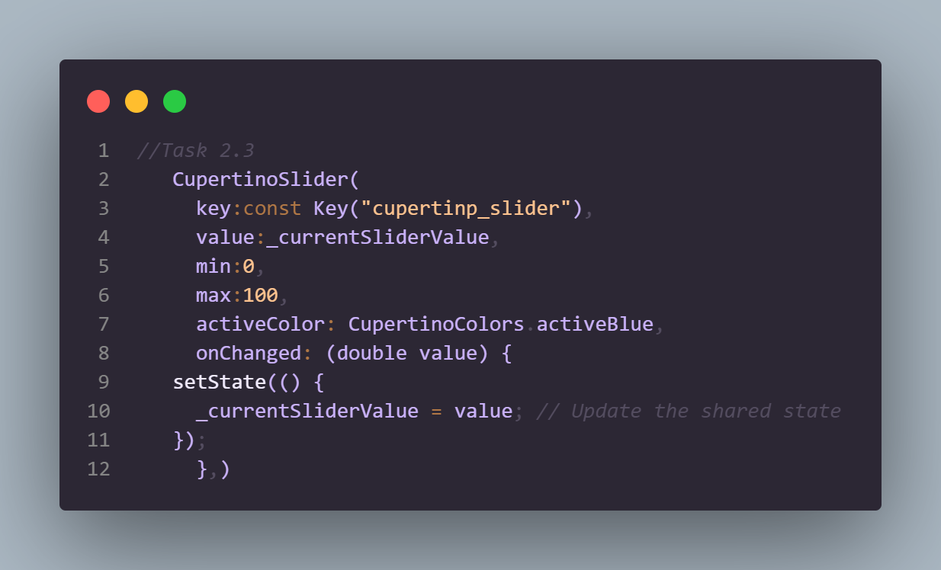
Phase 2 Output:
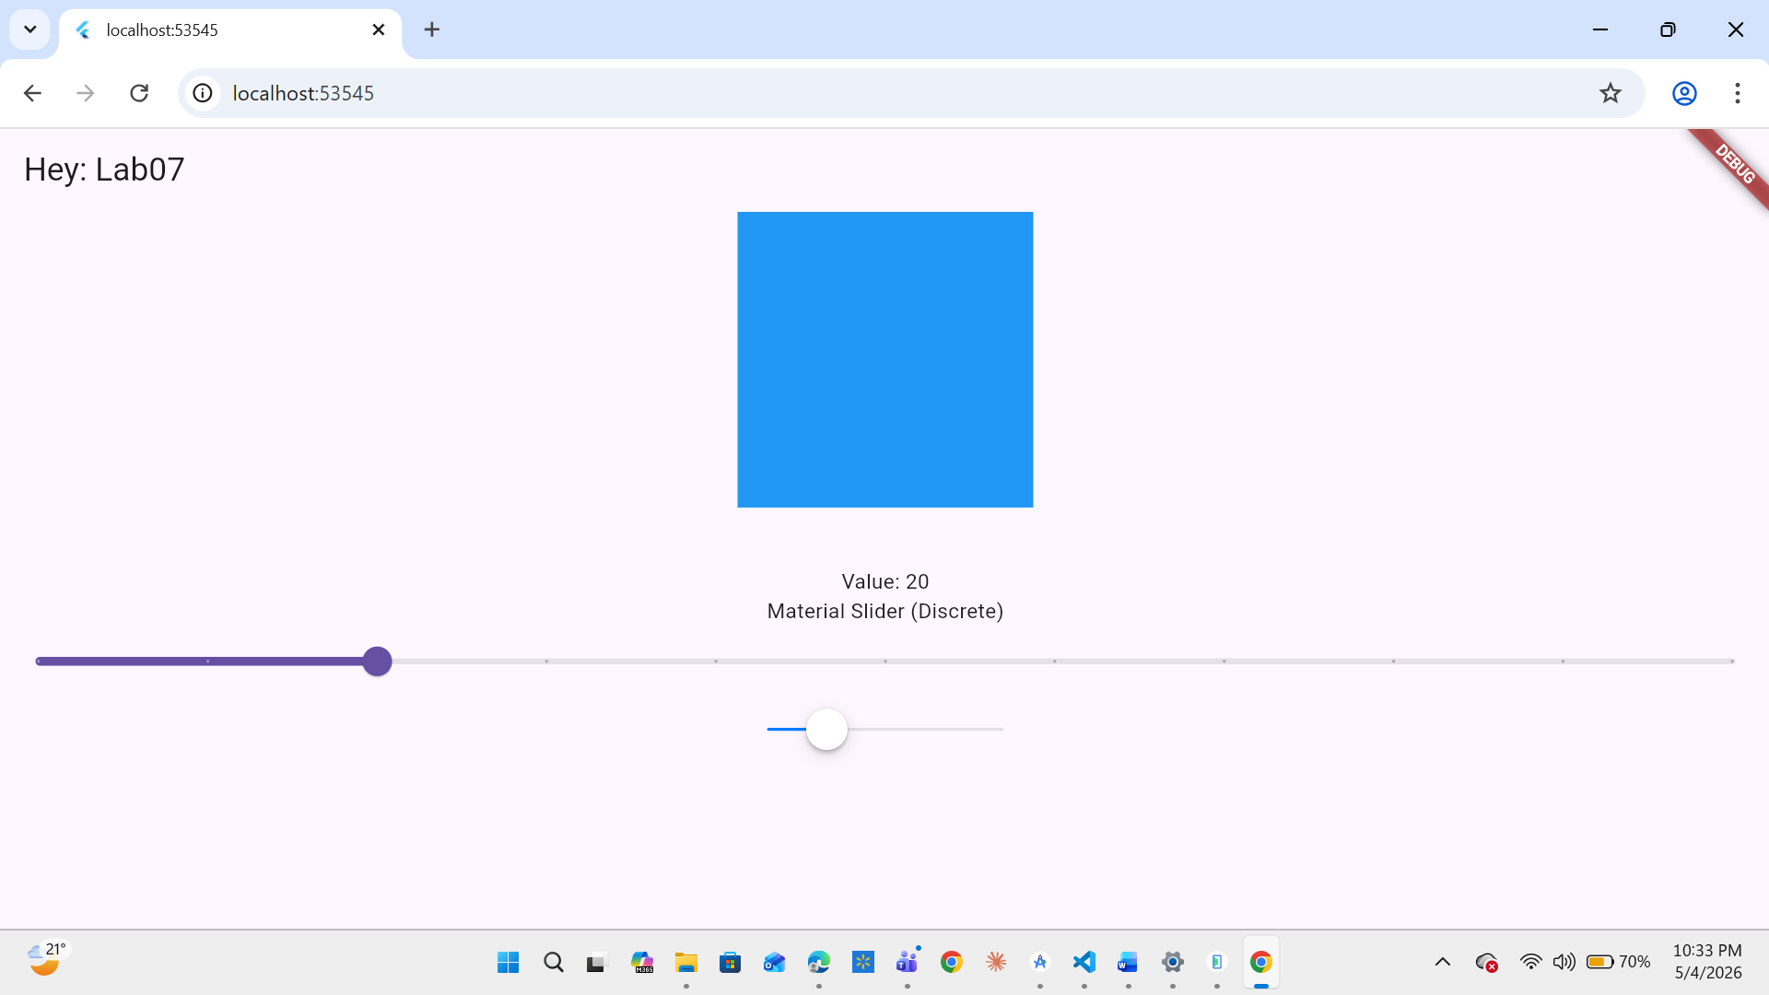

Phase 3: The "Mood & Color" Mixer
The Challenge: Build a mini-app on a single screen where:
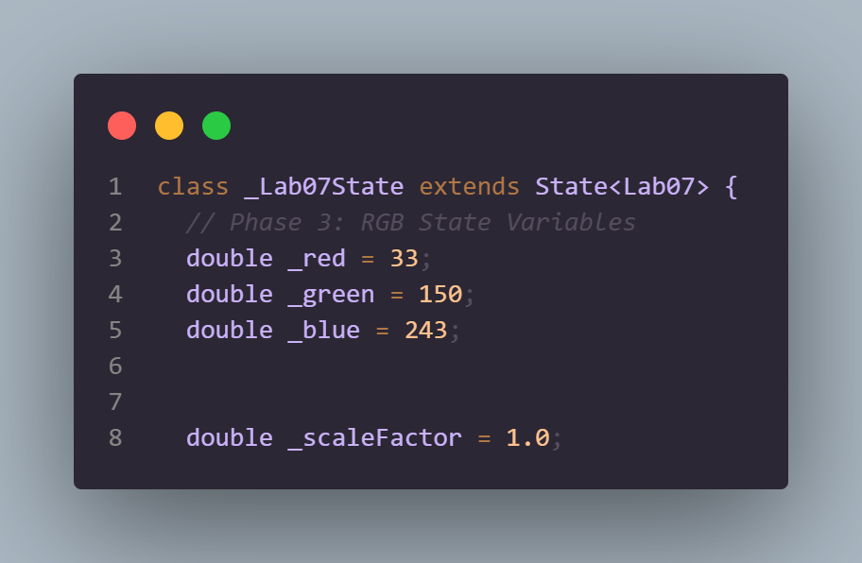
- The Challenge: Build a mini-app on a single screen where: 1. Three Sliders control the Red, Green, and Blue channels of a preview box.
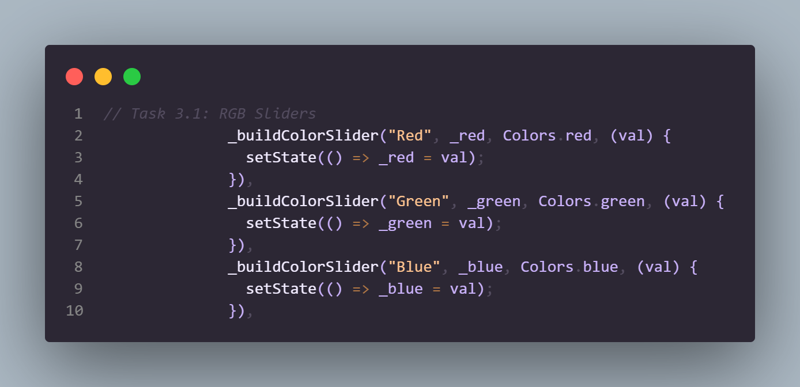
- A GestureDetector on the preview box allows the user to Long Press to "Copy" the Hex code to the console
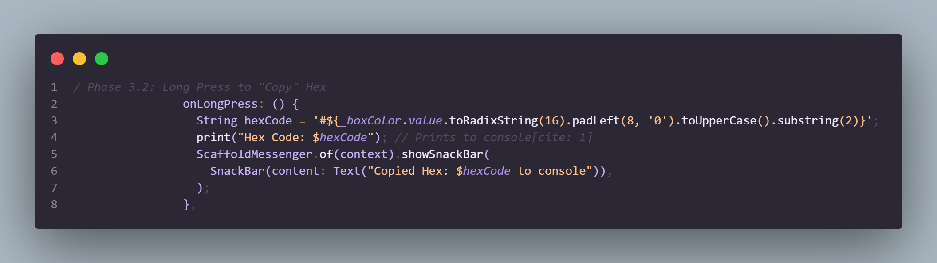
- Horizontal Drag (onHorizontalDragUpdate): Should scale the size of the preview box up or down.
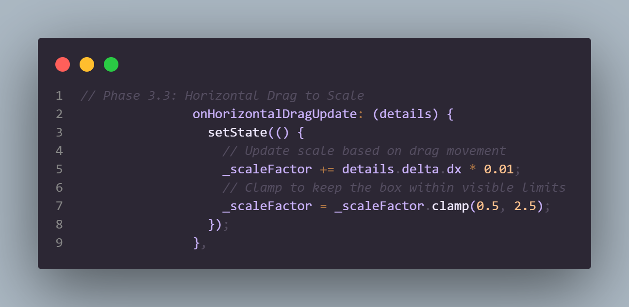

Phase 3 Output:
